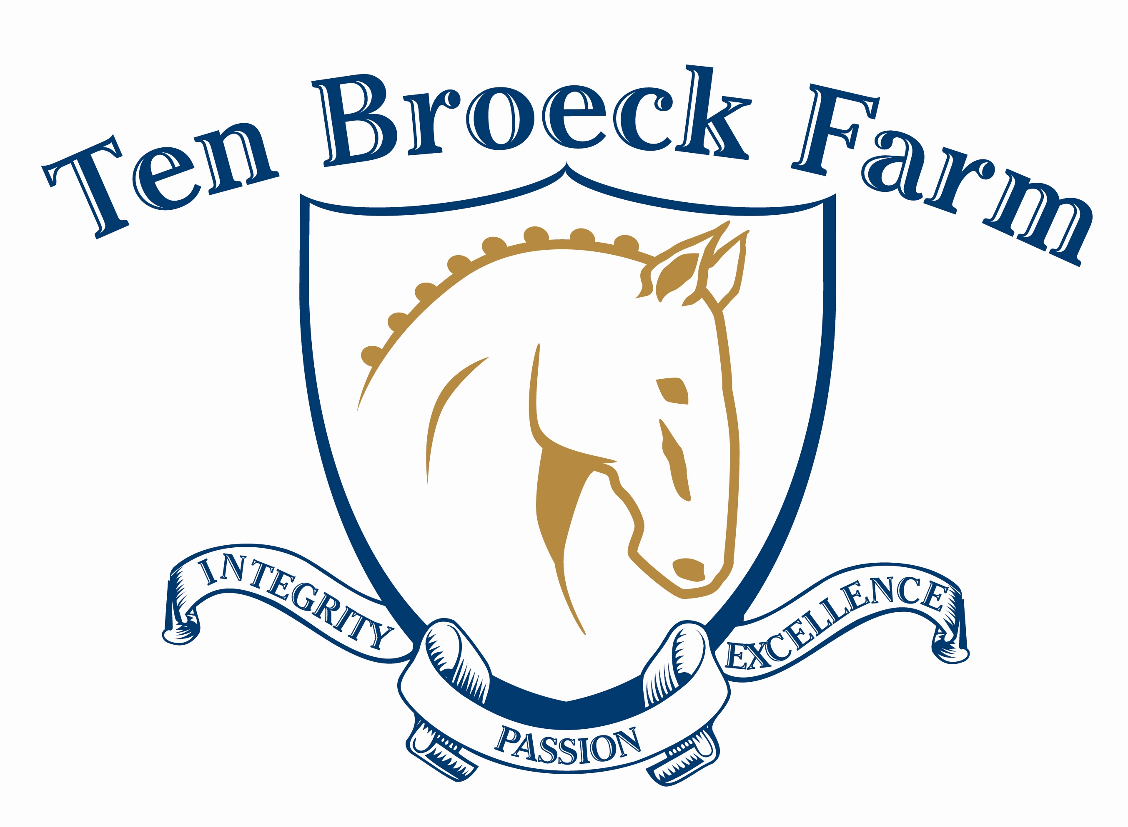

2013 SCHOOLING SHOWS

Ten Broeck Farm
2013 Schooling Series

Ten Broeck Farm ● 1 Old Farm Lane • Pepperell, MA • 01463 Rain or Shine (under cover)

Show Manager: Orintha Silva Phone: 978-877-6636 Email: tenbroeckfarm@charter.net

Sunday, April 21 Open/Closing date: March 21/April 14 Judge: Luis Reteguiz-Denizard “L
Sunday, June 16 Open/Closing date: May 16/June 9 Judge: Yvonn Colman-Larson “L”
Sunday, July 28 Open/Closing date: June 28/July 21 Judge: Ann Marie Gregoire “r”

USEF rules apply for all events

Please join us for an exciting schooling show season at Ten Broeck Farm. Each show will award six ribbons per class and present Champion and Reserve Champion high point of the day. Also, CASH PRIZES for Champion and Reserve High Point for the series (same rider/horse team; must compete in all three shows to be eligible).

Spirit awards will be given at each show on the centerline at lunch time. Dress your groom team up based on the show theme and have some fun with costumes and props while sharing some show spirit. Themes are as follows:
- April- Spring into Spring
- June- Summer Movies
- July- Red, White & Blue

ENTRY INFORMATION
Make checks payable to: Felisberto and Orintha Silva, LLC
Mail to: Orintha Silva, 1 Old Farm Lane, Pepperell, MA 01463
Fees: $35.00 per dressage test; FEI Tests $45.00. Late fee: $10 per test after closing date

- Entries must include payment and a negative Coggins within one year of show date
- Six ribbons awarded per class
- Classes may be divided and/or split as entries warrant
- Award for High Score and Reserve for the day
- One form per horse per show
- Times will be sent via email
- Entries accepted on a first-come-first-served basis. Show may fill before closing date.
- Protective helmets at all times when mounted

BANNER SPONSORSHIPS AVAILABLE
Get noticed! We’ll hang your banner in our indoor, you reach new customers.
$50.00 per show OR $100 for all three shows

Sponsor must supply, deliver and pick up banner.
Ten Broeck Farm
2013 Schooling Series

Ten Broeck Farm ● 1 Old Farm Lane • Pepperell, MA • 01463 Rain or Shine

REGISTRATION
Duplicate additional copies of entry form. One horse per entry form per show date. Signatures required on last page.
2013 SCHOOLING SHOWS

□ Sunday, April 21 □ Sunday, June 16 □ Sunday, July 28

RIDER
□ Adult □ Under 18
ADDRESS

CITY |  | STATE | ZIP
PHONE/CELL |  | EMAIL
EMERGENCY CONTACT PHONE CELL

HORSE NAME | OWNER
GENDER  □ M □ ST □ G | CLASSES |  | NOTES/COMMENTS:
Banner Sponsorship
Mail banner to Orintha Silva, 1 Old Farm Lane, Pepperell, MA 01463; or drop off during business hours. Pricing per banner.
□ April 21 - $50 □ June 16 - $50 □ July 28 - $50
□ Show Series (3 total) - $100

# of classes __________ @ $35.00 each = $___________________ Total $ ______________________

_________ FEI Tests @ 45.00 $ _________________ Make checks payable to:
Felisberto and Orintha Silva, LLC
Banner sponsorship $ __________________ Mail to: Orintha Silva
1 Old Farm Lane
Pepperell, MA 01463
Late fee $10.00 if applicable $ __________________

Class # Class # Class # Class #

1. Introductory Level Test A
13. Third Level Test 1
14. Third Level Test 2
15. Third Level Test 3
16. Fourth Level Test 1
17. Fourth Level Test 2
18. Fourth Level Test 3
19. FEI Test of Choice
Specify here

20. Western Dressage
7. First Level Test 1
8. First Level Test 2
9. First Level Test 3
10. Second Level Test 1
11. Second Level Test 2
12. Second Level Test 3

2. Introductory Level Test B
3 . Introductory Level Test C
4 . Training Level Test 1
5 . Training Level Test 2
6. Training Level Test 3

However, if a class is not filled, manager reserves the right to combine. Opening date is one month before the show. Closing date is in secretary’s hands 7 days prior to the show! After closing date late fee will be charged–no exceptions. A copy of negative coggins within 12 months must be sent with entry, or the entry is incomplete and will not be accepted. All dogs must be leashed.

Check www.tenbroeckfarm.net for accommodations, directions and more details
Ten Broeck Farm is sponsored by
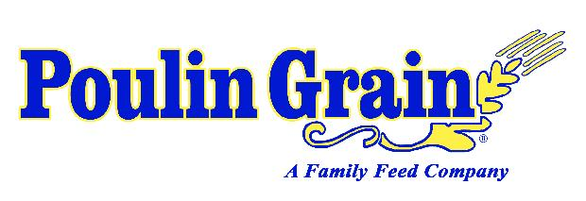
Massachusetts Clause
Under Massachusetts law, any equine professional is not liable for injury to, or the death of, a participant in equine activities resulting from the inherent risks of equine activities,
pursuant to section 2D of Chapter 128 of the General Laws.
WAIVER/RELEASE MUST BE COMPLETED, SIGNED & INCLUDED WITH ENTRY
Ten Broeck Farm Release, Assumption of Risk, Waiver and Indemnification
This document waives important legal rights. Read it carefully before signing.
I AGREE in consideration for my participation in the Competition for which this Entry Blank is used to the following:

I AGREE that I choose to participate voluntarily in the Competition with my horse as a rider, handler, longeur, lessee, owner, agent, coach, trainer, or as parent or guardian of a junior exhibitor. I am fully aware and acknowledge that horse sports and the Competition involve inherent dangerous risks of accident, loss and serious bodily injury including broken bones, head injuries, trauma, pain, suffering, or death.

With this knowledge and as an inducement for the landowners and organizers to allow me to ride on the grounds of the
Competition, I AGREE to release Ten Broeck Farm, Competition, the landowners, farms and any and all of their agents, employees, organizers, officials, directors, members, volunteers or officers (hereafter “the foregoing”) from all claims for money damages or otherwise for any Harm to me or my horse and for any Harm caused by me or my horse to others, even if the Harm resulted, directly or indirectly, from negligence of the foregoing.

I AGREE to expressly assume all risks of Harm to me or my horse, including Harm resulting from the negligence of the foregoing.

I AGREE to indemnify (that is, to pay any losses, damages, or costs incurred by) the foregoing and to hold them harmless with respect to claims for Harm to me or my horse, and for claims made by others for any Harm caused by me or my horse at the competition.

I have read Rules about protective equipment, including USEF Articles 318 and 1713, and DR120.5, as well as the NEDA Helmet Policy effective February 2011. I understand that I am required to wear an ASTM approved helmet at all times when mounted on a horse, while recognizing that no protective equipment can guard against all injuries.

If I am a parent or guardian of a junior exhibitor, I consent to the child’s participation and AGREE to all of the above provisions and AGREE to assume all of the obligations of this Release on the child's behalf.

I AGREE that Ten Broeck Farm and Competition as used above includes all of their officials, officers, directors, employees, agents,
personnel, volunteers and affiliated organizations.

BY SIGNING BELOW, I AGREE to be bound by all applicable Rules and all terms and provisions of this entry blank.
MANDATORY SIGNATURES OF PARTICIPANTS
No copies. No word “Same”. “R / H / L” indicates Rider / Handler / Longeur
Entries will not be accepted without mandatory signatures, full payment of fees, and legible proof of negative Coggins test
Any person (other than R / H / L) giving instruction, coaching, riding Horse at Event must sign below as Coach / Trainer

RIDER/HANDLER/LONGEUR (Mandatory) Signature Print Name

PARENT/GUARDIAN (Mandatory if R/H/L minor) Signature Print Name

OWNER / AGENT (Mandatory) Signature Print Name

COACH / TRAINER (If applicable) Signature Print Name

MANDATORY SIGNATURE PERTAINING TO HEAD PROTECTION
(Rider / Handler / Longeur must sign)
I AGREE TO WEAR AN ASTM APPROVED HELMET AT THIS EVENT AT ALL TIMES WHEN ON A HORSE

RIDER/HANDLER/LONGEUR (Mandatory) Signature Print Name

PARENT/GUARDIAN
(Mandatory if R/H/L minor) Signature Print Name

MEDICAL ALERT (i.e.: medication allergies)
Emergency Contact Emergency Phone Number

Ten Broeck Farm
2013 Schooling Series

Ten Broeck Farm ● 1 Old Farm Lane • Pepperell, MA • 01463

Photo Release

Photographs, videos, and/or audio clips may be taken of participants and spectators at activities held at Ten Broeck Farm. Ten Broeck Farm, and its representatives, request the right to use all photos, videos, and/or audio clips taken of youth, adults, animals, and activities. These may be used for local newspapers, promotional brochures and email marketing, promotional purpose on web sites, and to showcase equestrian programs.

By signing this form, I consent to allow Ten Broeck Farm, and its approved representatives, to use photos, videos, and/or audio clips that they have of me participating in events at Ten Broeck Farm with or without my name and for any lawful purpose, including for example such purposes as publicity and advertising. Additionally, I waive any right to royalties or other compensation arising or related to the use of these materials.

Print Name: _________________________________

Signature: __________________________________Date: _____________

Parent signature (if under 18) _____________________________ Date: __________

